Improving Adult ADHD Services in Greater Manchester

Consultation Survey
This survey is one of the ways you can get involved in the NHS Greater Manchester consultation on the future of ADHD services for adults.
Our consultation document sets out the work so far on adult ADHD services, including:
- Why we think these services need to change.
- How we developed the proposals
- What the options would mean in practice
- The differences and similarities between the options
To be able to fully answer the questions in the survey it is important that you read the background information on our website. You can also ring or email us and request that we send you a copy by post or email.
This survey has been created by NHS Greater Manchester. For our privacy notice, please visit: the NHS Greater Manchester integrated care website.
The questions are also available to answer online: www.gmintegratedcare.org.uk/get-involved.
If you need any help to complete or return the survey, please contact our team on 07786 673762 where you can leave a voicemail for us, or you can send a WhatsApp message (including voice notes) or text message on the same number. Alternatively, you can email us at gmhscp.engagement@nhs.net

The Questions
- What best describes you? (please tick)
I have been diagnosed with ADHD or am waiting for a diagnosis
I am a family member or carer of someone with ADHD
I am a professional
I am an interested member of the public
I want to respond on behalf of an organisation
Other (please tell us more) ………………………………………………………………..

- On a scale of 1-5, when thinking about ADHD services, how much do you agree or disagree with the following statements?
(Please tick a box for each statement)
 | Strongly disagree   | Disagree   | Neutral   | Agree   | Strongly agree  
Everyone with symptoms of ADHD should get support quickly.

The people who are having the most difficulties should get help first.

It is more important to help those most in need, than make sure that everyone gets support quickly.

- Is there anything that you would like to tell us about why you have given these answers?
……...…………………………………………………………………
……...…………………………………………………………………
……...…………………………………………………………………
……...…………………………………………………………………

Background information
We have 2 options that we are considering. We are going to ask you questions about each of these options.
The main difference between the options is when people get referred for triage and assessment. In Option A, people are referred straight for triage and assessment. In Option B, people are signposted to support tools and services and are only referred for triage and assessment if they need more help.
There is more information about these options before the questions.

Questions about Option A
Option A: Everyone with potential symptoms is referred for a face-to-face triage against referral criteria and then offered an appropriate level of support.
- People who meet the criteria go forward for assessment, diagnosis and treatment
- People who don’t meet the criteria get signposted to tools, peer support groups and services to help them manage their symptoms
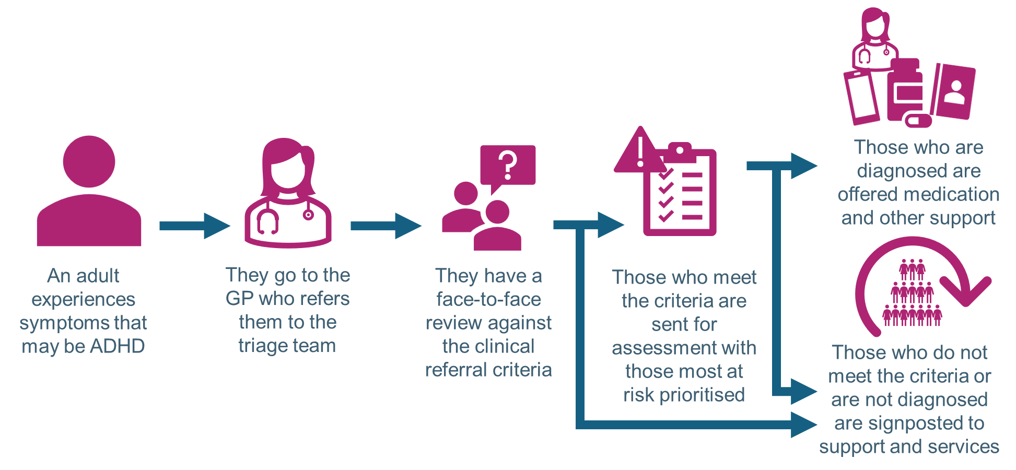

- How far you would agree or disagree with the following statements about Option A?
(Please tick a box for each statement)

 | Strongly disagree | Disagree | Neutral | Agree | Strongly agree
Option A will mean that patients get help more quickly.

Option A means that people who need help most will be seen first

Option A will mean people get more support

Option A will improve adult ADHD services

- Is there anything that you would like to tell us about why you have given these answers?
……...…………………………………………………………………
……...…………………………………………………………………
……...…………………………………………………………………
……...…………………………………………………………………

- Thinking about yourself, or people you know who have ADHD or are waiting for a diagnosis, how do you think the service described in Option A would impact them?
(Please tick one box)
It would be significantly worse than the current service | It would be worse than the current service | It wouldn’t be better or worse than the current service | It would be better than the current service | It would be significantly better than the current service
- Why do you think that?
Share any information that is relevant.
……...…………………………………………………………………
……...…………………………………………………………………
……...…………………………………………………………………
……...…………………………………………………………………
- Do you have any other thoughts that you would like to share with us on Option A?
……...…………………………………………………………………
……...…………………………………………………………………
……...…………………………………………………………………
……...…………………………………………………………………

Questions about Option B
Option B: Everyone with potential symptoms is first signposted to support tools and services. If these don’t help, they will then be referred for a face-to-face triage against the referral criteria and get offered an appropriate level of support.
- People who meet the criteria go forward for assessment for diagnosis and treatment
- People who don’t meet the criteria get signposted to tools, peer support groups and services to help them manage their symptoms
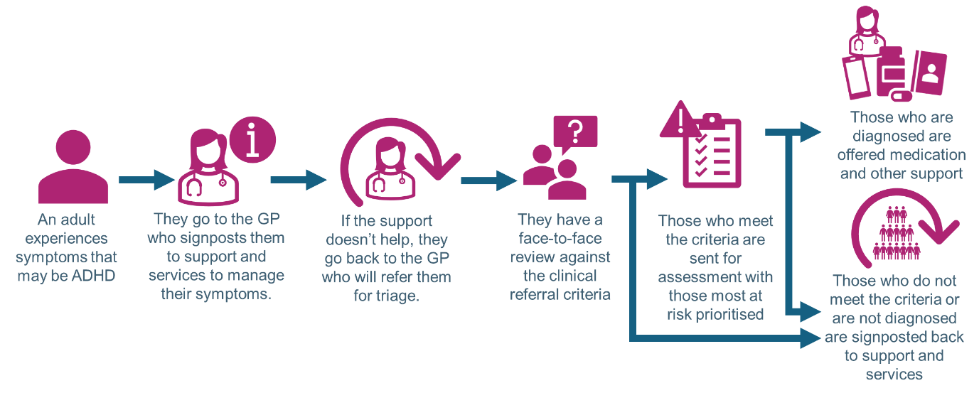

- How far you would agree or disagree that Option B would meet the following statements?
(Please tick a box for each statement)

 | Strongly disagree | Disagree | Neutral | Agree | Strongly agree
Option B will mean that patients get help more quickly.

Option B means that people who need help most will be seen first.

Option B will mean people get more support.

Option B will improve adult ADHD services

- Is there anything that you would like to tell us about why you have given these answers?
……...…………………………………………………………………
……...…………………………………………………………………
……...…………………………………………………………………
……...…………………………………………………………………
- Thinking about yourself, or people you know who have ADHD or are waiting for a diagnosis, how do you think the service described in Option B would impact them?
(Please tick one box)
It would be significantly worse than the current service | It would be worse than the current service | It wouldn’t be better or worse than the current service | It would be better than the current service | It would be significantly better than the current service

- Why do you think that?
Share any information that is relevant.
……...…………………………………………………………………
……...…………………………………………………………………
……...…………………………………………………………………
……...…………………………………………………………………

- Do you have any other thoughts that you would like to share with us on Option B?
……...…………………………………………………………………
……...…………………………………………………………………
……...…………………………………………………………………

Questions about the Preferred Option
- Our preferred option is Option A.
This is because people who are need help most urgently will get treatment faster in this option than in Option B. We think that this makes this makes the service safer.
Using the scale below, which option do you prefer?
(Please tick one box)
I definitely prefer Option A  A | I mostly prefer Option A  A | I don’t have a preference  A/B | I mostly prefer Option B  B | I definitely prefer Option B  B

- Can you please tell us why you chose that?
……...…………………………………………………………………
……...…………………………………………………………………
……...…………………………………………………………………
……...…………………………………………………………………

Questions about triage and support
- Both options involve a triage process using criteria to decide who will go forward for assessment for diagnosis for ADHD. The people who meet the criteria go on for a formal assessment for ADHD.

The referral criteria currently used elsewhere in the country that we are considering includes:
- There has been at least six months of experiencing five or more symptoms of hyperactivity and impulsiveness that are included in the standard Adult ADHD Self-Reporting Scale (ASRS).
- Some of the symptoms have been experienced since a young age, before the age of 12
- The symptoms are affecting at least two parts of life, for example, in education and work, or work and social situations, or education and social situations.
- There is evidence that some of the symptoms are making it hard for them to cope and function in work, education or normal social situations.
- The symptoms can’t be explained by another mental health condition.
- They have other severe mental or physical health problems

How much do you agree or disagree with this referral criteria?
Strongly disagree | Disagree | Neutral | Agree | Strongly agree
- Can you please tell us why you chose that?
……...…………………………………………………………………
……...…………………………………………………………………
……...…………………………………………………………………
……...…………………………………………………………………

As part of both options, people will be signposted to offers of support.
18. What types of support you would find useful?
(Please tick all that apply)
Help with anxiety
Help to help me eat healthy food
Help with my sleep
Help for my mental health
Help to drink less alcohol
Help to get me off drugs
Help to manage gambling
Help for sexual health
Something else, which is …...………………………………………………………………

19. How would you prefer to access support to help you manage your condition? (Please tick all that apply)
Through a face-to-face local community support group of people with the same experiences as me
Through an online local community support group of people with the same experiences as me
Through an app on my phone
Through a website on my phone or computer
Through an NHS service
On social media, like Facebook, Instagram or TikTok
Somewhere else, which is ……...……………………………………………………………
20. Are there any reasons why the proposed changes or either Option A or Option B might affect you in any way more than others?
For example, this could be because of your gender, for financial reasons, language barriers, disabilities, caring responsibilities, or any other reason.
……...…………………………………………………………………
……...…………………………………………………………………
……...…………………………………………………………………
……...…………………………………………………………………
21. Do you have any other thoughts or ideas about how we can improve Adult ADHD services that you would like to share with us?
……...…………………………………………………………………
……...…………………………………………………………………
……...…………………………………………………………………
…………………………..……………………………………………..

Equality Monitoring
We now have some questions about you. We need you help to monitor our engagement and who is answering our surveys. We want to make sure as many different people get involved and these questions help us.
Information shared is anonymous and we do not link the information you share with anything that could identify you. Please skip any questions that you do not want to answer or feel you cannot answer.
Please tick the boxes where appropriate
- In which borough or city do you live?
Bolton
Bury
Manchester
Oldham
Rochdale
Salford
Stockport
Tameside
Trafford
Wigan
Somewhere else (please tell us where):
4. How old are you?

- What is your ethnicity?
Please describe your ethnicity background however best fits you

- How do you identify your gender?

- Is your current gender identity the same as the gender you were described at birth?
Yes
No
Don't know
Prefer not to say
- What is your relationship status?
Co-habiting – Living with partner
Married / Civil Partnership
Single
Widow
Prefer not to say
Other (please can you tell us)

- What is your religion?
Atheist/ Non
Baha’i
Buddhist
Christian
Hindu
Jain
Jewish
Muslim
Pagan
Sikh
Zoroastrian
Prefer not to say
Other (Please can you tell us)

- Which of the following options best describes how you think of yourself?
Asexual
Bisexual
Gay man
Heterosexual / Straight
Lesbian / Gay woman
Pansexual
Prefer not to say
Other (please can you tell us)

- Do you consider yourself to have a disability?
(A disability is a condition that affects an individual’s ability to carry out normal day-to day activities. It can be a mental health or physical condition, visible or hidden, it can last 12 months or longer and be recurring.)
No

Prefer not to say
Yes (feel free to add further details below)
Comment:

- What is your employment status?
Employed / Self Employed
Unemployed
A student
Apprenticeship scheme or training
Long term sick or disabled
Homemaker looking after the family
In receipt of benefits
Voluntary work
Retired
Prefer not to say
Other (Please can you tell us)

- Are you or have you ever been a member of HM Armed Forces? (Regular or Reservist)
Yes, I am a current serving member of the Armed Forces
Yes, I am an Armed Forces Veteran (someone who has previously served in HM Armed Forces - regular or reservist)
No

- Are you a carer?
(A carer is someone who provides support to family or friends who couldn't manage without this help).
Yes

No
Prefer not to say

Thank you for completing this survey.
You can freepost (no stamp required) it back to us at:

Freepost Plus RUEL – TTGR – SCAJ:
Engagement Team, NHS GM (Salford),
Civic Centre, Chorley Road,
Swinton M27 5AS

Or scan and email us on gmhscp.engagement@nhs.net

