Improving Adult ADHD services in Greater Manchester
Consultation on options for change
31st March – 25th May 2025

Document control

Version | Date | Name | Amends
1 | 19.02.24 | Amanda Rafferty
2 | 27.02.24 | Alexia Mitton | Review and amends

Contents
Contents 2
Contact details 3
Introduction 4
What is NHS Greater Manchester (NHS GM)? 5
What is ADHD? 5
Why things need to Change 6
Increasing numbers of people coming forward and long waiting times 6
Finances 6
Variation in offers across Greater Manchester 7
Right to choose and private providers 7
Safety 7
Support and medication 7
Our vision for ADHD services 8
Our vision 8
How we believe that this will benefit patients 8
Who will be affected? 8
What we have done so far 9
The current services 9
Equality analysis 11
Patient feedback 11
Research and experience from elsewhere in England 12
Local policies and strategies 12
National policies and strategies 13
A new model of care 13
Referral criteria 14
A new triage team 15
Treatment and support 15
Impact on patients 16
What are the options for the future 16
Evaluating the options 18
Options for consultation 20
What do the options actually mean? 20
Reviewing the options against the standards 24
Which option will we choose? 26
Next steps 26
Why you should respond 26
How to get involved 26
How will the feedback be used? 27
Further information 27
Glossary 28
Accessibility & translations 29

Contact details
Please read this document carefully and give us your feedback on what you think of the proposals for changes to adults ADHD services in Greater Manchester. More information can be found on our website[LINK] or you can get in touch with us.
You can give your feedback by completing the survey [LINK] (on paper or online), you can write to us, email us, ring us, contact us through our social media, or come along to one of our focus groups.
You have until midnight on Sunday 25th May 2025 to give us your feedback.
Large print and easy read versions of this document can be found on our website, or you can ask that we email or post them to you using the contact details below. If you would like this document in a different language, or any other format (including braille and audio), or would like to be posted a hard copy, please contact us.

FREEPOST
NHS Greater Manchester, Engagement Team
The Tootal Building
Broadhurst House
56 Oxford St
Manchester
M1 6EU
Text, phone, WhatsApp: 07786 673762.
Email: gmhscp.engagement@nhs.net
Facebook: @NHS_GM
Instagram: @NHS_GM [LINK]
X (Twitter): @NHS_GM
www.gmintegratedcare.org.uk

Introduction
NHS Greater Manchester is responsible for commissioning (buying and overseeing) NHS health services across Greater Manchester. This public consultation is to seek feedback from you about the proposed options to improve Adult ADHD services in Greater Manchester
We are reviewing adult ADHD services because a lot more people are now being referred than the services were originally designed for. This means that waiting times are getting longer and because people are not getting support whilst they are waiting, some people are really struggling.
There is currently no single waiting list in Greater Manchester for adults waiting for ADHD services, so it difficult to say exactly how many people are currently waiting for an assessment. However, our best estimate is that there are over 15,000 people waiting, with that figure growing every day. If the service continues as it currently is, some people could be waiting over 7 years for assessment and diagnosis.
There is currently not system in place to understand which patients need to be prioritised and we have concerns that this could mean some people who are waiting desperately need help and are at risk of coming to harm.
If the demand for ADHD services continues at the current levels, it would also cost the NHS in Greater Manchester £8million a year to fund assessment services capable of meeting the demand.
For these reasons adult ADHD services in Greater Manchester need to change so they can better support the people who need them and we think that there are better ways to deliver these services so that they can quickly support the people who need them most. But there are no easy answers, as money is tight and there aren’t lots of extra staff, so we can’t simply increase the service to meet the increasing number of referrals.
This consultation is about two potential options for changing adult ADHD services. We want to hear your views on these proposed options to help inform our decision.
This consultation is not about ADHD services for children and young people. However, NHS Greater Manchester is also been working to address the future of ADHD services for children and young people. To find out more or to LINK.
Your responses will help to make sure we understand what is important to the people who may be affected by the proposed changes and what their needs are. It is important that we consider this when we make the final decision on the best option for changes to adult ADHD services.
Please read this information carefully and get involved either through completing the online survey, coming to a focus group, or calling or emailing us. For more detailed information, please visit our website, LINK call, text or WhatsApp us on 07786 673762, or email gmhscp.engagement@nhs.net.
A large print version of this document can be found on our website. If you would like this document in a different language, or any other format (including braille and audio), or would like to be posted a hard copy, please contact us.
This consultation will run from 31 March 2025 to ……….. It is open to anybody, but people with lived experience of ADHD are particularly encouraged to share their views. The outputs of the consultation will be fed into decision making by NHS Greater Manchester and the outcome published.

What is NHS Greater Manchester (NHS GM)?
NHS Greater Manchester (GM) is one of 42 Integrated Care Boards (ICBs) in England. ICBs are NHS organisations responsible for planning and commissioning health services for the local population.
This means that we have the job of deciding what health services are needed for people who live in Greater Manchester, funding health services that meet those needs, and monitoring the quality of the services that are delivered.
NHS GM covers Bolton, Bury, Manchester, Oldham, Rochdale, Salford, Stockport, Tameside, Trafford, and Wigan.

What is ADHD?
Attention Deficit Hyperactivity Disorder (ADHD) is a condition that affects people's behaviour. People with ADHD can seem restless, may have trouble concentrating and may act on impulse. Symptoms of ADHD tend to be noticed at an early age and may become more noticeable when a child's circumstances change, such as when they start school.
Most cases are diagnosed when children are under 12 years old, but sometimes it's diagnosed later in childhood. Sometimes ADHD was not recognised when someone was a child, and they are diagnosed later as an adult.
The symptoms of ADHD may improve with age, but many adults who were diagnosed with the condition at a young age continue to experience problems.
The exact cause of ADHD is unknown, but the condition has been shown to run in families. Research has also identified a number of possible differences in the brains of people with ADHD when compared with those without the condition.
For adults with ADHD, medicine is often the first treatment offered, although psychological therapies such as cognitive behavioural therapy (CBT) may also help.
Adults with ADHD may have problems with:
- organisation and time management
- following instructions
- focusing and completing tasks
- coping with stress
- feeling restless or impatient, and
- impulsiveness and risk taking
Some adults may also have issues with relationships or social interaction.
While some individuals with ADHD can thrive , others may face considerable challenges in their daily lives. Understanding that everyone’s experience is different is key to providing effective support and interventions.
It is important to understand that ADHD is a neurodevelopmental (not mental health) condition that cannot be ‘fixed’ by treatment. However, treatment for ADHD can help relieve the symptoms and make the condition much less of a problem in day-to-day life.

Why things need to Change

Increasing numbers of people coming forward and long waiting times
In Greater Manchester there are approximately 60,000 adults who may have ADHD.
As there is currently no single waiting list in Greater Manchester for adults awaiting ADHD assessment and/or support, it is difficult to say how many people are currently waiting for an assessment.
Our best estimate is that there are over 15,000 people waiting across Greater Manchester – with this figure growing daily – with many more people coming forward now than 5 years ago.
Despite more people coming forward for assessment, the evidence doesn’t suggest that there are more people with ADHD than 5 years ago. It is difficult to know why there are so many more people coming forward now, but it could be because of a number of reasons like:
- Increased public awareness and knowledge of ADHD leading to more recognition of adult ADHD symptoms
- Changes to lifestyles and work, with increased use of technology
- Cultural shifts in attitudes towards mental health
- Changes in how ADHD is diagnosed
To try and clear the waiting lists, we have paid for more ADHD assessments to be carried out. Whilst this has reduced the number of people who have been waiting a very long time, the overall waiting list has continued to increase because there are more people joining than there are available appointments.
In Greater Manchester, approximately 8,000 adults were referred for an ADHD assessment in the last 12 months, most of whom have not yet had an assessment.

Finances
A diagnostic assessment for ADHD costs between £700 and £1400 per person. Based on this, it would cost the NHS in Greater Manchester at least £15million to see everyone who is currently on the waiting list, and this cost is growing every year.
If the demand for ADHD services continues at the current levels, it would also cost the NHS in Greater Manchester £8million a year to fund assessment services capable of meeting the demand.
This is both unaffordable and unsustainable given the financial constraints currently in place for the NHS in Greater Manchester and a lack of people qualified in this area of specialism. .
NHS Greater Manchester Mental Health NHS Foundation Trust have recently reported that if the service continues as it currently is, some people could be waiting over 7 years for assessment and diagnosis, which is not acceptable.

Variation in offers across Greater Manchester
Adult ADHD services are not offered consistently across Greater Manchester and there is lots of variation in both the number of providers, NHS access, and the quality of the offer depending on where you live.

Right to choose and private providers
The increasing waiting times are leading more people to demanding access to specialist assessment and diagnosis from a variety of private providers via Right to Choose arrangements. Right to Choose means that if your GP needs to refer you for a physical or mental health condition, in most cases you have a legal right to choose the hospital or service you’d like to go to.
Whilst many of these clinics offer a good service, staffed by professionals, it is important to consider the potential for financial incentives to lead to over-diagnosis and over-prescribing - posing risks to patients as well as the health system.
There are also challenges for people with right to choose or private diagnosis getting access to medication through the NHS, with many GPs uncomfortable about prescribing the continuing medication without patient management plans and clear ways to raise safety concerns.

Safety
We have concerns about the safety of the current situation as a large number of people are being referred for assessment but are then going unassessed for long periods. Services are seeing patients in the order they are added to the waiting list, but there is currently no prioritisation of the patients on the waiting list or checks to see if someone has deteriorated.

Support and medication
There is evidence to suggest that patients with less severe ADHD symptoms may not need medicine. Some people may benefit from access to self help materials, talking therapies or peer support, but currently medication is the only support and treatment that is offered to people diagnosed with ADHD. This is against a backdrop of medication shortages.
The lack of wider support was a strong theme emerging from engagement with the public. Participants felt strongly about the need to signpost to sources of support throughout their journey, including prior to potential diagnosis and treatment, (including self-help, websites etc. which are also accessible for family members). Some patients are waiting for long durations of time and described the need for coping mechanisms to support their daily life whilst they were waiting to be appropriately diagnosed.
PUT QUOTE FROM ENGAGEMENT ABOUT LACK OF SUPPORT
For all the reasons described above, adult ADHD services in Greater Manchester need to change so they can better support the people who need them.

Our vision for ADHD services

Our vision
We want to improve access to support, diagnostics and treatment for ADHD and we want this to be equitable and consistent across Greater Manchester.
We want a service that understands and responds to the needs of individuals and is not a ‘one size fits all’. This includes an offer of support for everyone and a diagnosis for those who need it most.
We will achieve this by:
- Prioritising access for individuals on the waiting lists who are in the most clinical need
- Introducing a newly commissioned Greater Manchester Adult ADHD Triage Team of Mental Health Practitioners who would undertake face-to-face detailed assessments in support of initial GP consultations
- Implementing a Triage Assessment Process model that supports GPs and patients by prioritising those patients who are most at risk and have the highest clinical need, with clear criteria for eligibility for NHS-funded assessments and treatment
- Ensuring there is an appropriate support offer for people who do not meet the criteria for diagnosis but feel they would benefit from this

How we believe that this will benefit patients
This means that people will wait less time to receive the support and treatment they need. Support will be available much earlier in the patient journey and they will not have to wait for a formal diagnosis to access it. It also means that those who need help most are prioritised for assessment and diagnosis earlier and prevent their symptoms worsening.

Who will be affected?
ADHD has been typically thought of as a condition with school age boys. However, whilst more men and boys than women come forward for treatment and diagnosis, the latest evidence shows that this condition can affect anyone.
We believe there are approximately 60,000 people in Greater Manchester with ADHD, with over 15,000 of these currently on a waiting list.
Any changes to these services will affect the 15,000 people on the waiting lists and anyone who comes forward for diagnosis in the future.
From the evidence we have looked at, and the engagement we have carried out, the following groups of people are more likely to be affected by ADHD and any changes we make to the services:
- Young people transitioning to adults services, and those heading to college, university and into the workplace
- Women who are pregnant and with young children
- People who struggle with the cost of living and live in deprived communities
- People with autism and/or other neurodiverse conditions
- People with learning difficulties or learning disabilities
- People with histories of struggles with alcohol or drugs
- People who are in or have experience of the criminal justice system as children or adults
We will work hard to reach these communities through the consultation.

What we have done so far
Before we launched this consultation, we did a lot of work to understand the current situation and what the impact of any changes might be. This included:
- Made sure we understood how the current services work
- Carried out an equality analysis to see if some groups are affected more than others
- Undertook engagement with people and communities to understand current needs and experience
- Established a lived experience group to act as a sounding board and provide advice and guidance throughout the engagement and consultation
- Researched what has been done elsewhere locally and nationally
- Considered local and national policies
Find out more on these in the sections below.

The current services
People aged 18 and over with symptoms of ADHD across Greater Manchester are referred to ADHD services by their GP.
The GP will ask about symptoms, when they started, where they are experienced (for example, at home or at work), if there have been any recent significant events and if there is a history of ADHD in the family.
They may then refer for an assessment if, for example:
- The symptoms cannot be explained by a mental health condition.
- The symptoms significantly affect the patient’s day-to-day life – e.g. underachieving at work or finding intimate relationships difficult.
- The patient was not diagnosed with ADHD as a child, but the symptoms began during childhood and have been ongoing since.
- They were diagnosed as a child but now need more support or medication because symptoms are getting worse.
After referral, patients will usually sit on a waiting list for quite some time – years in some cases. Patients are then seen for assessment on a first-come-first-served basis with no means of identifying who is most urgent or escalating their diagnosis or treatment.
At their assessment, the patient will be seen by an appropriately qualified healthcare professional with training and expertise in the diagnosis of ADHD, usually a psychiatrist.
For an adult to be diagnosed with ADHD, their symptoms should also have an impact on different areas of their life, such as:
- underachieving at work or in education
- driving dangerously
- difficulty making or keeping friends, and
- difficulty in relationships with partners
If the person is diagnosed with ADHD, treatment can be given to make the condition less of a problem in day-to-day life. Currently, this treatment is the prescribing of strong, performance enhancing medications. There is no other support on offer.
If the person isn’t diagnosed with ADHD, then they get no other offer of help or support, even if they may still be experiencing the symptoms that led to them asking for a referral.

Image 1. The current service

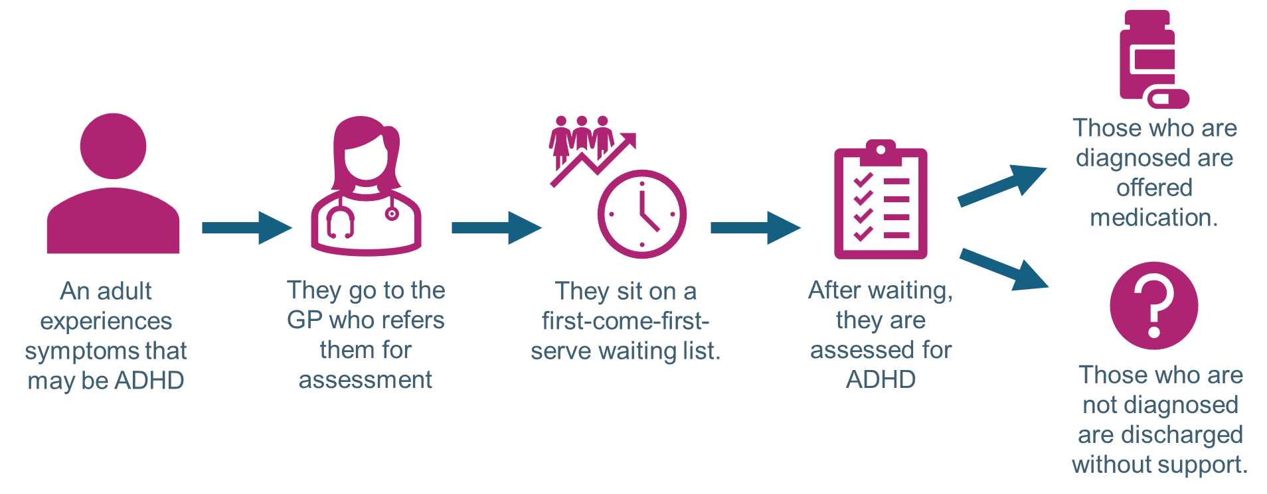

Equality analysis
The equality analysis we carried out highlighted, amongst other things, the difficulties experienced accessing support and seeking reasonable adjustments without a diagnosis, the challenges faced by adolescents transitioning to adult services, and the often different presentations of women to men, meaning they can feel misunderstood and marginalised by services.
We also found that cultural differences, language barriers and differences in acceptance of ADHD mean that minority ethnic patients may be less willing to come forward, and be less able to self-advocate through a triage process.
The key implications for a future service model included the need for services to be culturally sensitive and take into account the needs of people who are socio-economically disadvantaged or who have chaotic lifestyles. The analysis also showed that any assessment criteria used would need to be mindful of different ADHD presentations shown by women.
The analysis demonstrated the need for any future consultation on this topic to employ a whole population approach with specific work to address minority ethnic communities (to get a proportionate number of responses), younger men, middle aged women and the economically disadvantaged.

Patient feedback
Engagement included a survey which received 464 responses as well as a range of other activities. The three key engagement themes were communication, support and diagnosis.
Participants highlighted the need to improve the communication they received whilst on the waiting list including confirming that they were still on the list and how long they may still have to wait, as well as the need to improve communication between providers.
They felt strongly about the need to signpost sources of support throughout their journey, including prior to potential diagnosis and treatment, (including self-help, websites etc. which are also accessible for family members). There was evidence of people turning to unverified and potentially misleading online platforms due to a lack of authoritative, clinically assured sources of information.
Participants also emphasised that they valued diagnosis as a means to open the doors to support. Examples were given around support at university, adjustments in the workplace and perceptions from the wider public of ‘being lazy’ or not being taken seriously. This has led to us thinking more about how people can receive practical help and advice without diagnosis.
Unfortunately, most participants struggled to identify something positive about their experiences of NHS ADHD services. However, once people were able to enter the pathway, they commented on how good the healthcare professionals had been. When asked what could make their experience better, participants said to reduce the duration of the process including the time taken to be assessed.
To read the full engagement report LINK

Research and experience from elsewhere in England
All health systems in England are experiencing the same challenges with their adult ADHD services. Some places have already started to try new ways of working and redesign their services.
For example, Cheshire and Wirral have reviewed their services and have introduced a new model where patients are triaged after they are referred. They have also introduced a way to prioritise referrals so those who need help most get it more urgently. Training and extra support for GP practices is being offered too.
We believe that this model could be adapted for Greater Manchester and enable safer practice and ensure that those with the highest need are prioritised.

Local policies and strategies
Greater Manchester has some of the lowest life expectancy in England, with differences between the most and least deprived areas of 9.5 years for men and 7.7 years for women.
Further differences exist between communities according to race and ethnicity, gender, disabilities, poverty and social exclusion, sexuality and age, as shown through a range of external analyses. This, coupled with increasing demand and a workforce crisis, is putting strain on our services.
Residents have told us they have real concerns about funding and staffing levels, difficulties in accessing appointments, and waiting times for hospital care.
Greater Manchester’s Integrated Care Strategy sets out how we will work together to improve the health of our city-region’s people through the Greater Manchester Integrated Care Partnership.
It outlines our priorities (our ‘missions’) which are to:
- Strengthen our communities
- Help people get into – and stay in – good work
- Recover core NHS and care services
- Help people stay well and detect illness earlier
- Support our workforce and our carers
- Achieve financial sustainability
It also sets out a commitment to make continuous improvements in access, quality and experience – and reduce unwarranted variation (the “postcode lottery”).
This review into ADHD services needs to support the priority to achieve financial sustainability and also the commitment to reduce unwarranted variation in services across the city-region.

National policies and strategies
ADHD services are challenging across the country, with very few areas meeting the current National Institute for Health and Care Excellence (NICE) guidelines. These guidelines emphasise the need for comprehensive care plans that include psychological, behavioural, and educational interventions alongside drug treatments.
A national task force has been set up by NHS England to support improvements. The taskforce aims to address challenges spanning the healthcare, education, and justice sectors by engaging stakeholders including patients, service providers, and educational institutions.
NHS Greater Manchester is actively engaged in supporting the work of the national Taskforce. We are confident that our direction of travel in Greater Manchester is consistent with this work.

A new model of care
As set out in our vision, we want to develop a service that reduces the waiting time and prioritises those who need help most urgently.
We know that we can’t keep up with the ever-increasing number of people being referred for assessment, and so we need to focus on assessing and diagnosing the people who need medical help most, but make sure that everybody who needs it gets offered appropriate support to help them manage their condition.
To do this, our new model of care:
- Is needs-led, helping people to manage their symptoms so they can live a better life
- Creates one service across Greater Manchester that has a consistent approach to referral, assessment and diagnosis, through a central team of specialists who will review and triage all referrals through a face-to-face appointment.
- Has reduced waiting times for assessment by introducing specific clinical criteria for those who should be referred for an assessment, as there are in other services across the NHS.
- Prioritises those most urgently in need and sees them faster, to make sure that patients are safe and not at risk of coming to harm.
- Offers more than medication in the offer of support for those diagnosed, and offers tools to help people manage their symptoms.
- Has an offer of support for everyone who needs help with symptoms, rather than just those who are diagnosed.

Image 2. An overview of the model of care
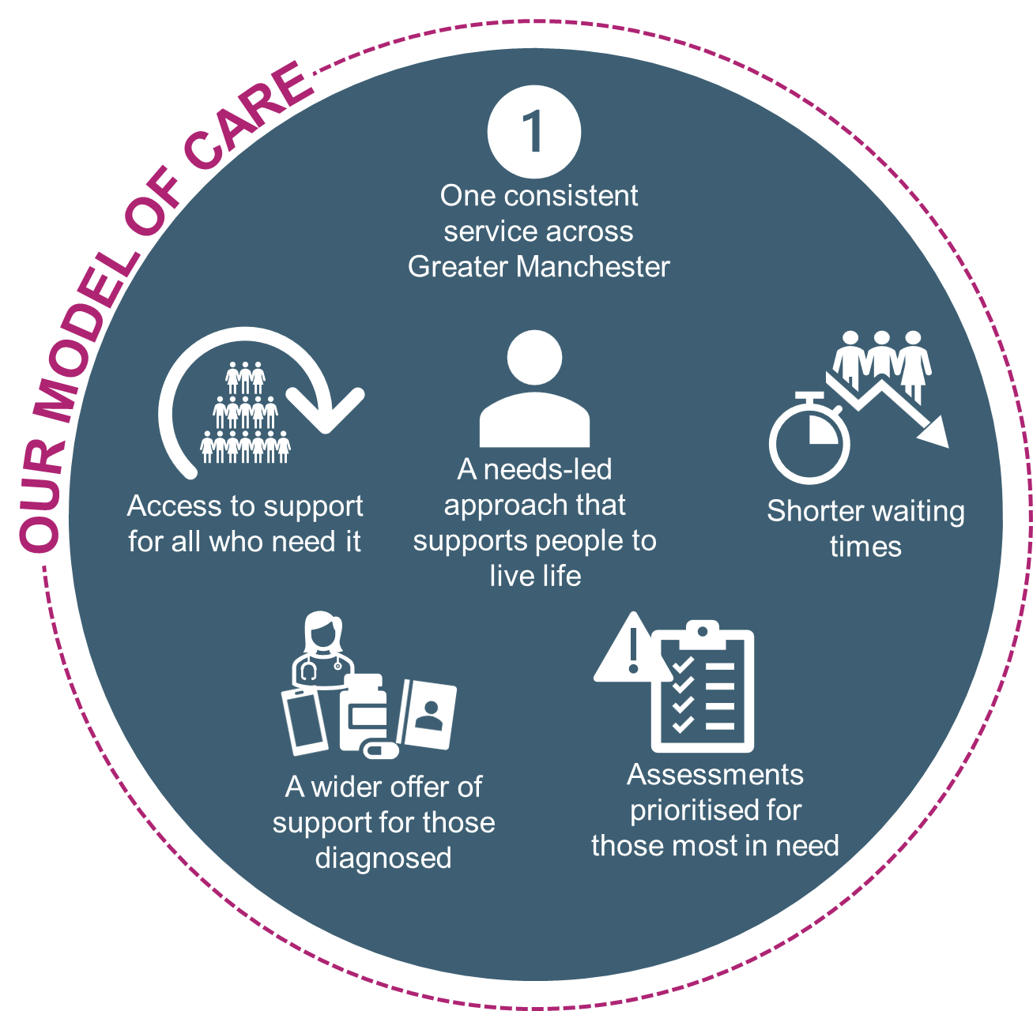
The right to choose offer would remain, and all patients would be able to choose who to go to for assessment either after they are triaged, or if they are waiting over 40 weeks.

Referral criteria
Referral criteria is used by GPs, psychologists and other health professionals to understand if a referral is the right option for a patient. It is nearly always based on the patient’s health, symptoms and medical conditions.
Referral criteria are very common and are used in nearly all NHS services to help GPs and other professionals to decide whether a patient should be referred to a particular service. They help make sure that decisions are made consistently by lots of different health professionals.
Currently there are no referral criteria for ADHD services, so anyone who feels they have some experience of symptoms of ADHD can be referred and join the waiting list for assessment.
The new model of care includes referral criteria to make sure that referrals are made consistently and for those whose symptoms make a difference to their life. These referral criteria will be applied by trained health professionals in the new triage team that is being created. GPs will continue to use the same initial checks as currently before referring on to the triage team.
Evidence from places that have already done this suggests that 20-30% of current referrals would meet the referral criteria for assessment for ADHD, with the other 70-80% being signposted to tools and services that would help them manage their symptoms and improve their quality of life.
This way of managing referrals makes sure that those whose symptoms impact the most on their life get assessed and treated more quickly, whilst everyone gets offered help to manage any symptoms.
Some groups of people will automatically get referred due to the increased risks to harm, including veterans and young people transitioning from children to adult services.
The referral criteria currently used elsewhere in country that we are considering includes:
- There has been at least six months of experiencing five or more symptoms of hyperactivity and impulsiveness that are included in the standard Adult ADHD Self-Reporting Scale (ASRS).
- Some of the symptoms have been experienced since a young age, before the age of 12
- The symptoms are affecting at least two parts of life, for example, in education and work, or work and social situations, or education and social situations.
- There is evidence that some of the symptoms are making it hard for them to cope and function in work, education or normal social situations.
- The symptoms can’t be explained by another mental health condition.
We want feedback through the consultation on this criteria, so please give it some consideration.

A new triage team
Under the new model all referrals from GPs will go to a triage team of specialist, trained health professionals. Their job will be to apply the referral criteria to all the referrals. This will be done through face-to-face appointments.
The patients who meet the criteria will be sent on for assessment, diagnosis and treatment – as they currently are. Those who do not will be signposted to a range of tools and services that may help them to manage their condition.
The triage team will also prioritise the waiting list so those who are at most risk of coming to harm because of the ADHD and whose symptoms are most severe are seen fastest.

Treatment and support
Evidence from across the country and through engagement with local communities has shown that when people have less severe symptoms of ADHD, a medical approach to neurodiversity with the only treatment or offer being strong medication can be the wrong approach.
Instead, we want to help people to access support that will help them to manage their symptoms so they can lead their life easier.
This means that, those not prioritised or referred for assessment, would be signposted to self-help, peer support, online resources and existing services like talking therapies in mental health services.
We will also signpost people to tools and support whilst they are waiting for their triage appointment or assessment, so people aren’t left to cope without help or advice.
For those who are diagnosed, medication will still be offered should it be the most appropriate treatment, but wider services to help them manage their symptoms will also be offered.

Impact on patients
We recognise that the introduction of referral criteria and triage is likely to have a considerable impact on patients – especially those already on the waiting list who are expecting to go straight for assessment.
However, in considering the suitability of such a model, we need to balance this against the very clear patient benefits:
- Shorter waiting times.
- Care based on need and risk with people presenting with severe difficulties, distress et, will have their diagnosis and treatment prioritised, resulting in them being seen sooner and reducing the risk of harm.
- The development of a wider offer of non-medical support to help people manage symptoms.
- The avoidance of over-medicalising and over-prescribing for neurodiversity.

What are the options for the future
We considered all the different ways we could improve ADHD services across Greater Manchester, meeting the new model of care and reducing waiting times, making it quicker for those who need it most to get support and treatment. Each of these ways was called an option.
8 potential options were originally identified and they are set out below.
Option 1: Do nothing and make no change
Make no changes to the service which currently exists.
Option 2: A face-to-face review against referral criteria with support for those diagnosed
Introduce referral criteria that people must meet to get assessed for diagnosis and offered treatment and support. With:
- People who meet the criteria go forward for assessment, diagnosis and treatment
- People who don’t meet the criteria get discharged with no further support
Option 3: A face-to-face review against referral criteria with support for everyone
Introduce referral criteria that people must meet to get assessed for diagnosis and offered treatment and support. With:
- People who meet the criteria go forward for assessment, diagnosis and treatment
- People who don’t meet the criteria get signposted to tools, peer support groups and services to help them manage their symptoms
Option 4: Support for everyone with a face-to-face review against referral criteria and triage for assessment only undertaken after the support doesn’t work
Everyone who is referred is first signposted to tools, peer support groups and services to help them to manage their symptoms. If this support doesn’t help, people then get triaged against the referral criteria for assessment for diagnosis and treatment.
Option 5: An online self-assessment review against referral criteria with support for just those diagnosed
Introduce referral criteria with an online referral criteria tool that people complete by themselves that people must meet to get assessed for diagnosis and offered treatment and support. With:
- People who meet the criteria go forward for assessment, diagnosis and treatment
- People who don’t meet the criteria get discharged with no further support
Option 6: An online self-assessment review against referral criteria with support for everyone
Introduce referral criteria with an online referral criteria tool that people complete by themselves that people must meet to get assessed for diagnosis and offered treatment and support. With:
- People who meet the criteria go forward for assessment, diagnosis and treatment
- People who don’t meet the criteria get signposted to tools, peer support groups and services to help them manage their symptoms
Option 7: Fund a bigger service
Fund additional staff/teams to be able to clear the waiting list and offer diagnosis to everyone going forward.
Option 8: Stop the service
No longer fund adult ADHD services and stop the service completely.

Evaluating the options
These 8 options were evaluated against a list of standards (criteria) to understand if they were viable and could be delivered. The standards included creating a safe service, being affordable, offering a consistent service across GM, creating an accessible service, and having enough staff to deliver it, amongst other things.
There are 2 sets of standards that options were evaluated against: gateway standards that every option must meet; and, evaluation standards of important things that we want to consider the options against, but they aren’t required to meet in order to be viable.
The standards were developed by the Lived Experience Advisory Group and the Project Group and the full list with more detail can be found in tables 1 and 2.

Table 1: The gateway standards and the evidence considered
Standard | Description | Evidence considered
Affordability | Whether the option could be delivered within the same cost as the current service. | The estimated service cost under the option.
Safety of patients | Whether the option would create a safe service for patients and reduce waiting times | Waiting lists  Patient safety hub evidence  Concerns raised by GP practices and coroner’s courts
Equal access across Greater Manchester | Whether the option would provide the same access to NHS services across every area in Greater Manchester. | Service offer across Greater Manchester under each option

Table 2: The evaluation standards and the evidence considered
Standard | Description | Evidence considered
Workforce | Whether there are enough staff to deliver the option. | Estimated workforce requirements compared to the current service
Support for all | Whether the option provides an offer of support for all patients who are referred. | Level of support will be available for people who are referred
NICE guidelines | Whether the option meets the NICE guidelines. | The NICE guidelines
Health inequalities | Whether the option will reduce health inequalities. | Equality impact assessment
More information about the standards and the evidence that we used can be found on our website [LINK].
Following this evaluation and a final review through governance, the outcome for each of the options can be found in table 2.

Table 2: The outcomes of review for the options
# | Option | What happened | Outcome
1 | Do nothing and make no change | This option was ruled out because it does not create an equal service across Greater Manchester. | 
2 | A face-to-face review against referral criteria with support for just those diagnosed | This option was ruled out because it was not considered a safe service if people who don’t meet the criteria wouldn’t get offered any support.
3 | A face-to-face review against referral criteria with support for everyone | This option met all the standards and so is part of this consultation. | 
4 | Support for everyone with a face-to-face review against referral criteria and triage for assessment only undertaken after the support doesn’t work | This option met all the standards and so is part of this consultation.
5 | An online self-assessment review against referral criteria with support for just those diagnosed | This option was ruled out because it was not considered safe to have self-assessment online without a professional and because people who don’t meet the criteria wouldn’t get offered any support.
6 | An online self-assessment review against referral criteria with support for everyone | This option was ruled out because it was not considered safe to have self-assessment online without a professional.
7 | Fund a bigger service | This option was ruled out because we can’t afford to fund a bigger service.
8 | Stop the service | This option is ruled out because it not the intention of NHS Greater Manchester to stop all access to ADHD services.
More information about the outcome of the evaluation can be found on our website [LINK].

Options for consultation
As a result of the review of the options, the options we are consulting on are:
Option A (our preferred option): A face-to-face review against referral criteria with support for everyone
And
Option B: Support for everyone with a face-to-face review against referral criteria and triage for assessment only undertaken after the support doesn’t work
There is more information about each of these options below, and information about how the options compared against the standards can be found in table 3.

What do the options actually mean?

OPTION A (our preferred option): A face-to-face review against referral criteria with support for everyone

Image 3. The service under option A
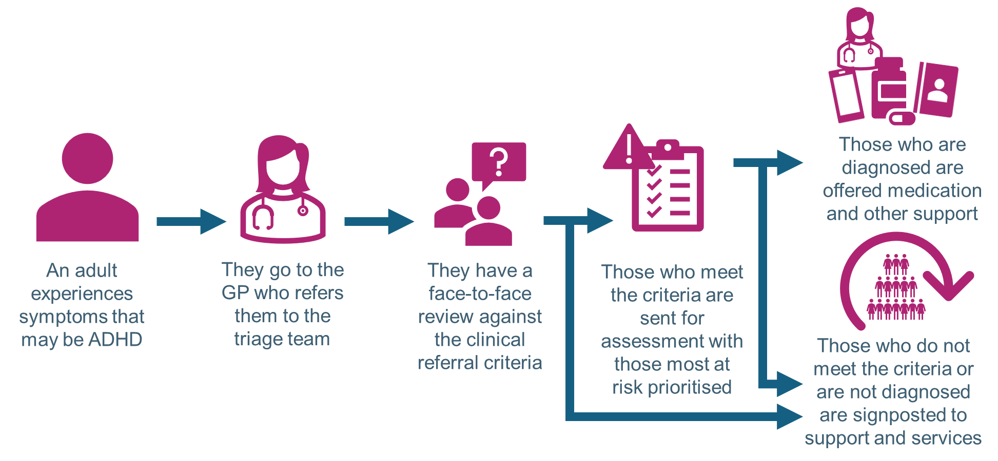
In this option, an adult who is experiencing symptoms that might be ADHD will go to their GP.
Their GP will then refer them to an expert ADHD triage team. The team will invite them to a face-to-face appointment where they will talk with them and explore their symptoms, experiences and health. This will then be reviewed against clinical referral criteria.
If they meet the criteria they will be sent for assessment and diagnosis for ADHD. Those who are experiencing the worst symptoms will be prioritised for assessment and will be seen faster.
If the adult is then diagnosed, they will be offered medication or other services and support to help them manage their symptoms. If the adult doesn’t meet the referral criteria, or isn’t diagnosed after assessment, they will be signposted to support like self-help tools, apps, peer support groups, and other services like talking therapies.
It is expected that about 20-30% of people who are reviewed against the criteria will go on to be assessed and diagnosed.

Table 4: Risks and benefits of this option
Benefits | Risks
- This option prioritises those in greatest clinical need and who need the service most.  - It meets the NICE guidelines  - This option should improve the service quality.  - It will create a safer service with those who urgently need help getting it.  - There will be lower waiting times and reduced risks for the people on the waiting list.  - Long term it will save money once everyone on the waiting list has been triaged.  - There will be an equal offer for people across Greater Manchester with everyone having access to an NHS triage. | - This will take some time to get set up and implement.  - The referral criteria will reduce the number of people who go forward for a potential diagnosis.  - Some people who do not meet the threshold following triage may go on to use a private service.  - For those who meet the criteria, different localities will have different providers in place to deliver the assessment and diagnosis service (or the patient would have Right to Choose).

Preferred option
This option is our preferred option for the future of adult ADHD services. This is because people who are at risk of harm will be reviewed faster in this option than in option B, meaning that they will get the help they need more quickly.

OPTION B: Support for everyone with a face-to-face review against referral criteria and triage for assessment only undertaken after the support doesn’t work

Image 4. The service under option B

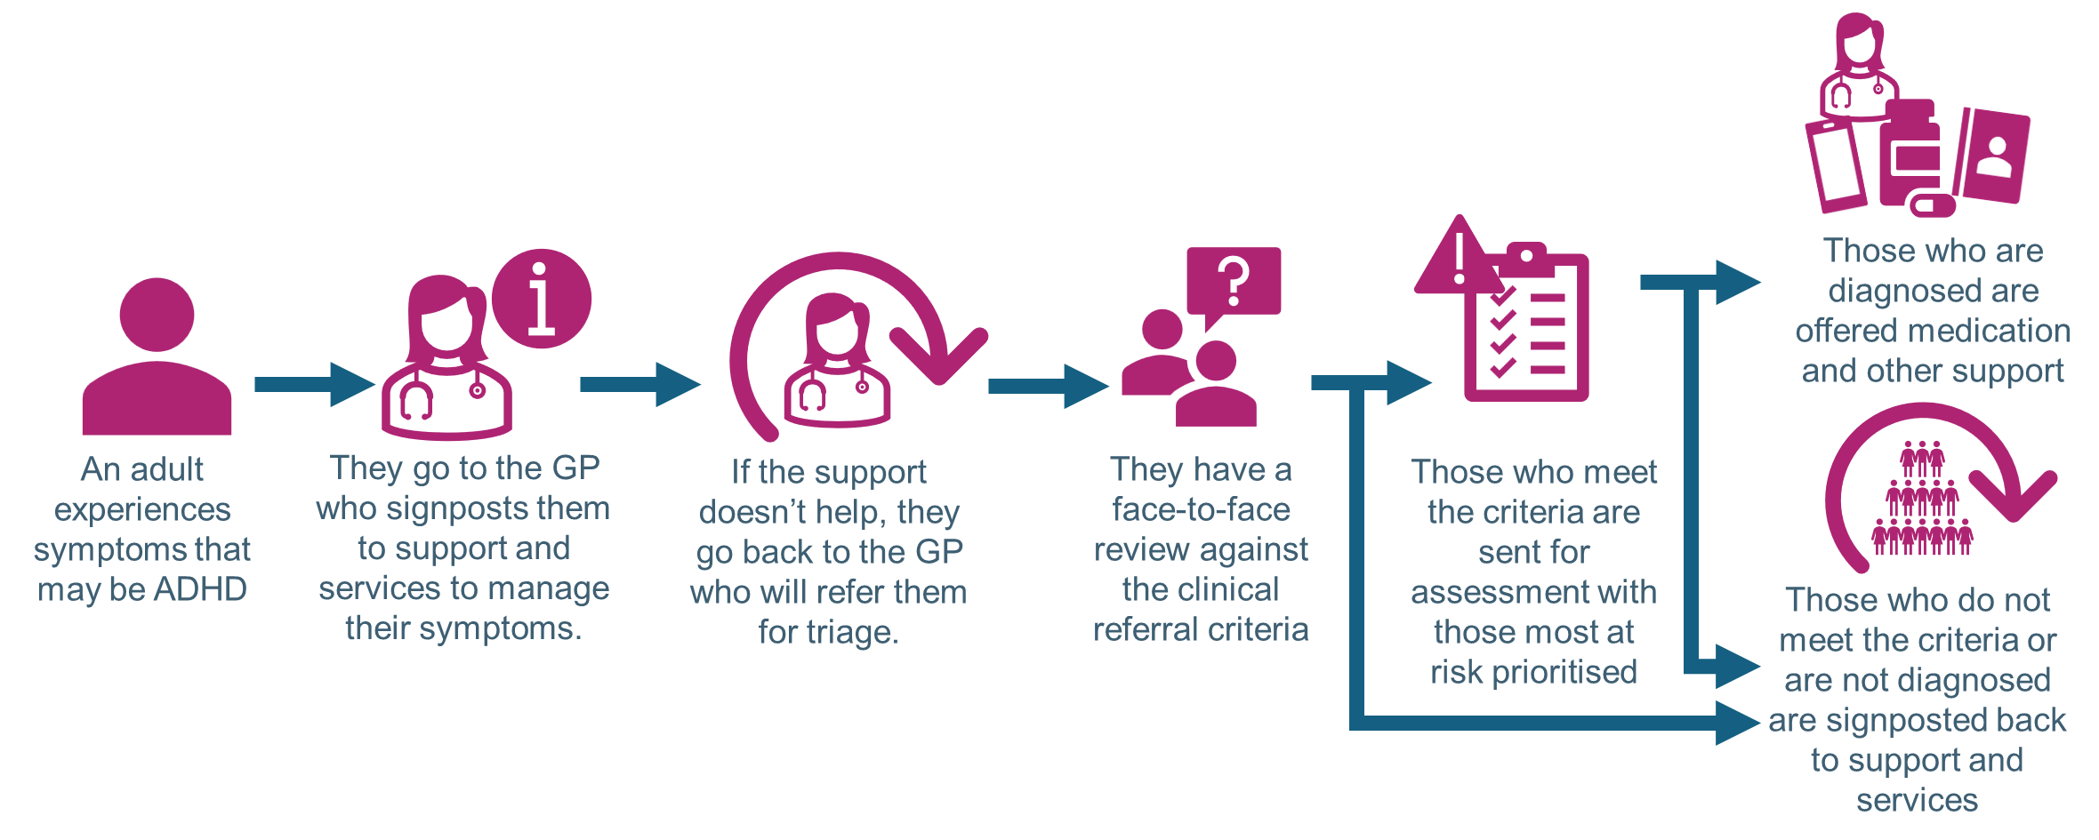

In this option, an adult who is experiencing symptoms that might be ADHD will go to their GP.
Their GP will then signpost them to support like self-help tools, apps, peer support groups, and other services like talking therapies. This is to help them manage their symptoms.
Most people are expected to find that this helps them live a better quality of life, but if they are still experiencing challenges, they can go back to their GP.
Their GP will then refer them to an expert ADHD triage team. The team will invite them to a face-to-face appointment where they will talk with them and explore their symptoms, experiences and health. This will then be reviewed against clinical referral criteria.
If they meet the criteria they will be sent for assessment and diagnosis for ADHD. Those who are experiencing the worst symptoms will be prioritised for assessment and will be seen faster.
If the adult is then diagnosed, they will be offered medication or other services and support to help them manage their symptoms. If the adult doesn’t meet the referral criteria, or isn’t diagnosed after assessment, they will be signposted to support like self-help tools, apps, peer support groups, and other services like talking therapies.
It is difficult to know for this model, but it is still expected that about 20-30% of people who are reviewed against the criteria will go on to be assessed and diagnosed.

Table 4: Risks and benefits of this option
Benefits | Risks
- Fast support offered to everyone without waiting.  - This option prioritises those in greatest clinical need and who need the service most, although only after trying the initial support offer.  - It meets the NICE guidelines .  - This option should improve the service quality.  - This is likely to reduce the waiting times more as some people will get the help they need without needing to be reviewed or assessed.  - Long term it will save money once everyone on the waiting list has been triaged.  - There will be an equal offer for people across Greater Manchester with everyone having access to an NHS triage. | - This will take some time to get set up and implement.  - This process could make the journey to accessing diagnosis a longer one, therefore increasing the risk of harm for those need higher levels of support more quickly – although it is still expected to be quicker than the current service.  - This option will be more expensive than the previous option as everyone will go through the support offer first.  - Some people may not be happy with the support offer and push for the next stage without trying it.  - The referral criteria will reduce the number of people who go forward for a potential diagnosis.  - Some people who do not meet the threshold following triage may go on to use a private service.  - For those who meet the criteria, different localities will have different providers in place to deliver the assessment and diagnosis service (or the patient would have Right to Choose).

Reviewing the options against the standards

Table 3: Overview of the options for consultation
Option | Option A: A face-to-face review against referral criteria with support for everyone | Option B: Support for everyone with a face-to-face review against referral criteria and triage for assessment only undertaken after the support doesn’t work
Affordability  (The current service costs approximately £15million) | It will cost approximately £4.5million to set up and triage team and do assessments for everyone on the waiting list.  It will then cost approximately £1.6million every year after that to run the service.  These costs do not include any funding for additional support offers, but the saving on the current service will provide money for this. | It will cost approximately £4.5million to set up and triage team and do assessments for everyone on the waiting list.  It will then cost approximately £1.6million every year after that to run the service.  These costs do not include any funding for additional support offers, but the saving on the current service will provide money for this.
Safety of patients | Will reduce waiting times and prioritises those who need the service most, but offers support for everyone. | Will reduce waiting times and offers support for everyone quickly, but would potentially create a delay on prioritising those most in need.
Equal access across Greater Manchester | Creates an equal service across GM | Creates an equal service across GM
Workforce | Long term this will use the existing staff, but in a different way, but at first will need a new small team to clear the waiting list. | Long term this will use the existing staff, but in a different way, but at first will need a new small team to clear the waiting list.
Support for all | About 20-30% will get a diagnosis and treatment, but everyone will be offered support. | It is difficult to tell how many will go forward for a diagnosis and treatment, but everyone will be offered support.
NICE guidelines | Meets the NICE guidelines. | Meets the NICE guidelines.
Health inequalities | It is expected that this will reduce health inequalities by making the service more accessible and consistent. | It is expected that this will reduce health inequalities by making the service more accessible and consistent.

Which option will we choose?
Whilst we have a preferred option, at the moment we don’t know which option we will choose because we need more feedback – that is why we are running this consultation.
We are holding the consultation to understand whether this is the right decision, and whether there is any information and impacts that we haven’t yet considered. We also need to understand if you think there is another option for the future of the practices that we haven’t considered.
The feedback you give us will inform our decision and help us to make the right choice.

Next steps
After the consultation has closed, time will be taken to consider all the feedback and information given to us. A report will be produced and published online.
This report, alongside further evidence and a recommendation, will be taken through our governance process, with the NHS Greater Manchester Board taking the final decision. This meeting will be held in public.
After this, we will work with GP practices and service providers to implement the agreed option.

Why you should respond
It is very important that we understand what is important to everybody who has an interest in the future of adult ADHD services. We can only make a decision based on the information we have. If you have some thoughts, some things you wish us to consider, you need to let us know so that we can take them in to account.
You can also tell us if you think there is another option that we haven’t considered.
The feedback you give us will inform our decision and help us to make the right choice.

How to get involved
We have worked closely with professionals, services, patients and other key stakeholders to get to this stage.
We now want to hear from more from our communities, in particular people with experience or and interest in adult ADHD services and professionals to understand what you think about our plans.
There are several ways in which you can have your say, all options will allow you to share your thoughts and experiences, feel free to use one or more of the options:
- Complete the survey:
- Attend one of our focus groups, contact us or visit our website for dates:
- Contact us by email to share your thoughts/experience on gmhscp.engagement@nhs.net.
- Contact us by phone, text of Whatsapp on 07786 673762.
We look forward to hearing from you.

How will the feedback be used?
After the consultation we will review all of the information and feedback given to us and a report will be published on our website.
We will also update the Equality Impact Assessment (EIA), so we can be sure that we have a good understanding of the impact of any changes on different communities and demographics.
The EIA, the report and all the feedback will be used to inform the decision on how many cycles we should be offering across Greater Manchester.
The decision will be taken by NHS GM’s Board[???]. It is their job to consider the impact of any changes on people who need them, the staff who deliver them, and also the impact on the quality of the service and the costs.

Further information
There is a lot more information on our website for you to look [LINK] at if you wish and we have referenced some in several places in the document. If you would like hard copies of any information on our website, or you would like it in any alternative formats or languages, please get in touch with us; our contact details are at the beginning of the document.

Glossary
ADHD

Consultation
A public consultation offers patients, people and communities a formal opportunity to comment and influence plans to change services in the NHS. This consultation is about NHS-funded IVF cycles.
Clinicians
Doctors, nurses, consultants, or any other health care worker who treats patients directly.
Health inequalities
Health inequalities are unfair and avoidable differences in health across the population, and between different groups within society. These include how long people are likely to live, the health conditions they may experience and the care that is available to them.
NHS Greater Manchester
NHS Greater Manchester are responsible for commissioning most health services across Greater Manchester, including hospital, community and mental health services, GP practices, dentists, optometrists, and pharmacists. This means that they are responsible for managing the contracts, making sure they deliver good quality care, and paying for the NHS services that they deliver.
NICE
The National Institute for Health and Clinical Excellence (NICE) provides national guidance and advice to improve health and social care.

Accessibility & translations
If you would like this information in another format, or translated into a different language, please email gmhscp.engagement@nhs.net
如果您希望以其他格式获得此信息，或将其翻译成其他语言，请发送电子邮 件至 gmhscp.engagement@nhs.net
Jeżeli chciał(a)byś otrzymać te informacje w innym formacie lub w innej wersji językowej, prześlij wiadomość na adres gmhscp.engagement@nhs.net
Pour obtenir ces informations dans un autre format ou dans une autre langue, veuillez adresser un e-mail à gmhscp.engagement@nhs.net
إذا كنت ترغب في هذه المعلومات بتنسيق آخر، أو مترجمة إلى لغة أخرى، يرجى إرسال gmhscp.engagement@nhs.net إلى اإللكتروني بالبريد رسالة
ਜੇਕਰ ਤੁਸੀਂ ਇਸ ਜਾਣਕਾਰੀ ਨੂੰ ਕਿਸੇ ਹੋਰ ਫਾਰਮੈਟ ਵਿੱਚ, ਜਾਂ ਕਿਸੇ ਹੋਰ ਭਾਸ਼ਾ ਵਿੱਚ ਅਨੁਵਾਦ ਕਰਨਾ ਚਾਹੁੰਦੇ ਹੋ, ਤਾਂ ਕਿਰਪਾ ਕਰਕੇ gmhscp.engagement@nhs.net ‘ਤੇ ਈਮੇਲ ਕਰੋ
اگر کسی اور فارمیٹ، میں یا کسی اور زبان میں ترجمہ شدہ آپ کو یہ معلومات چاہیے، تو براہ کرم پر ای میل gmhscp.engagement@nhs.net
Haddii aad rabto in aad macluumaadkan ku hesho qaab kale, ama lagu soo turjumo luqad kale, fadlan farriin iimayl u dir gmhscp.engagement@nhs.net
Dacă doriţi aceste informaţii în alt format sau traduse într-o altă limbă, vă rugăm să trimiteţi un e-mail la gmhscp.engagement@nhs.net
আপনি যদি এই তথ্যটি অন্য ফর্ম্যাটে বা অন্য ভাষায় অনুবাদ করতে চান, তাহলে অনুগ্রহ করে এখানে ইমেল করুন gmhscp.engagement@nhs.net
Si desea recibir esta información en otro formato o que se traduzca a otro idioma, envíe un mensaje a la dirección gmhscp.engagement@nhs.net

